**Superstore Sales Performance - Capstone Project**

**View 1: Total Sales,**

**View 2: Total Profit,**

**View 3: Total Volume,**

**View 4: Sales Per Customer**

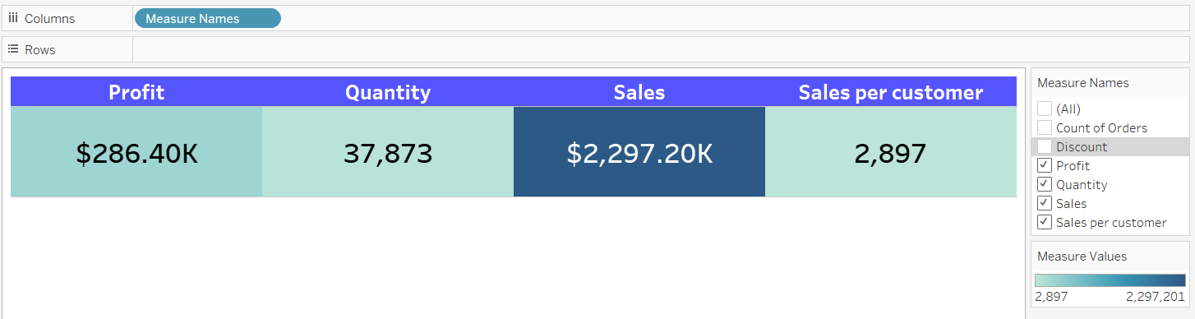

**View 5: Pie Chart should display the percent of Total Sales by Region.**

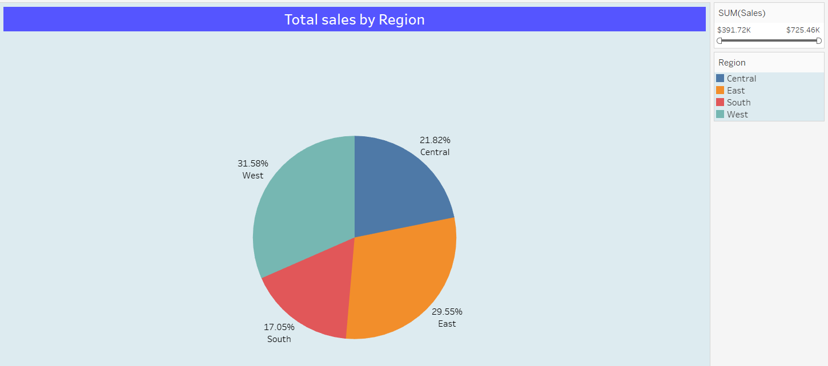

**View 6: Horizontal Bar Chart should display the top N states by Sales.**

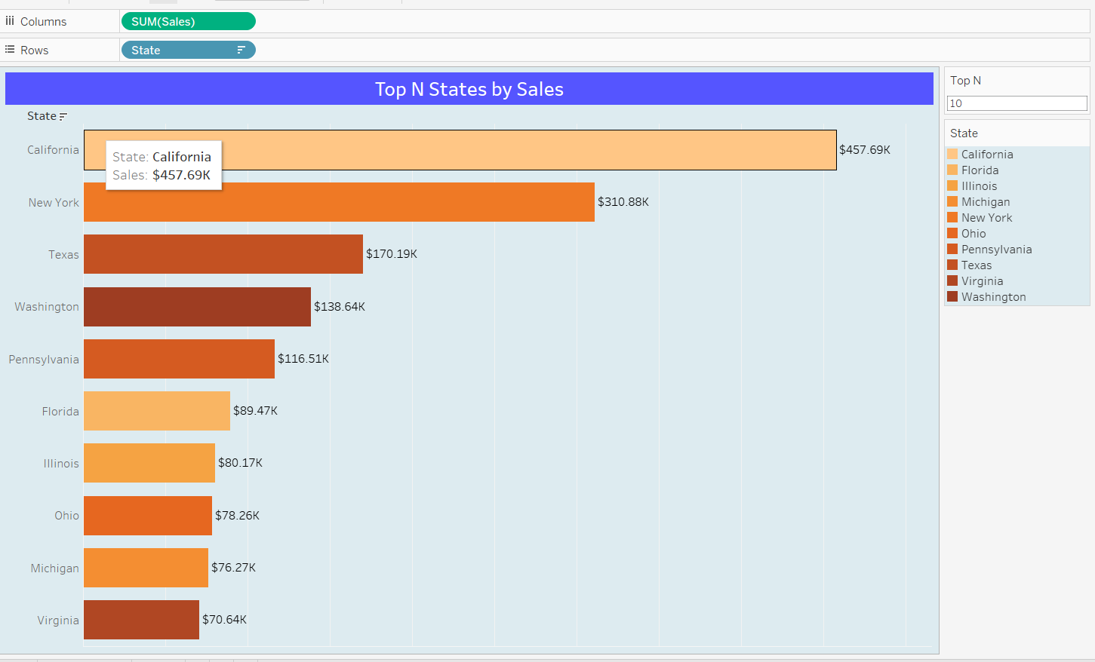

**Bubble chart should display Sales by sub-category.**

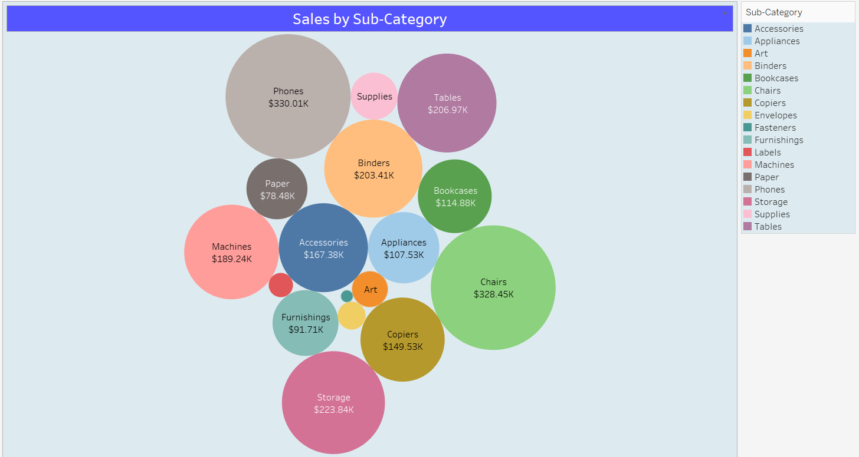

**line chart should display the Sales trend by Month-Year.**

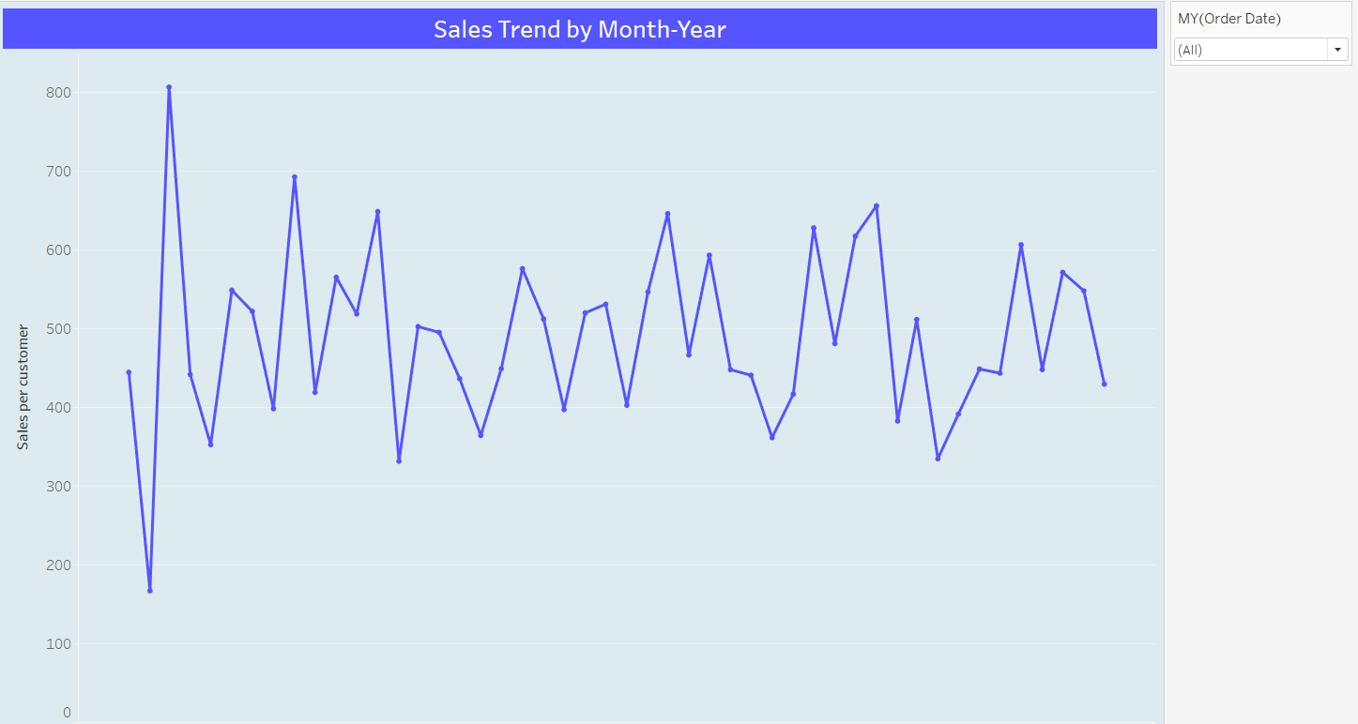

**Final Dashboard**

